Project Design Phase Proposed Solution Template

Date Team ID
Project Name Maximum Marks
3 December 2025

SHOPEZ : E-commerce Application 2 Marks

Proposed Solution for Medifolio - Doctor Appointment Booking System

S. No. 1
Parameter
Problem Statement (Problem to be solved)
Description

Customers often struggle to find the right products, compare prices, check stock availability, and complete purchases smoothly. Sellers face difficulties managing product listings and inventory.
There is no single, unified platform that connects customers, sellers, and admins efficiently with real-

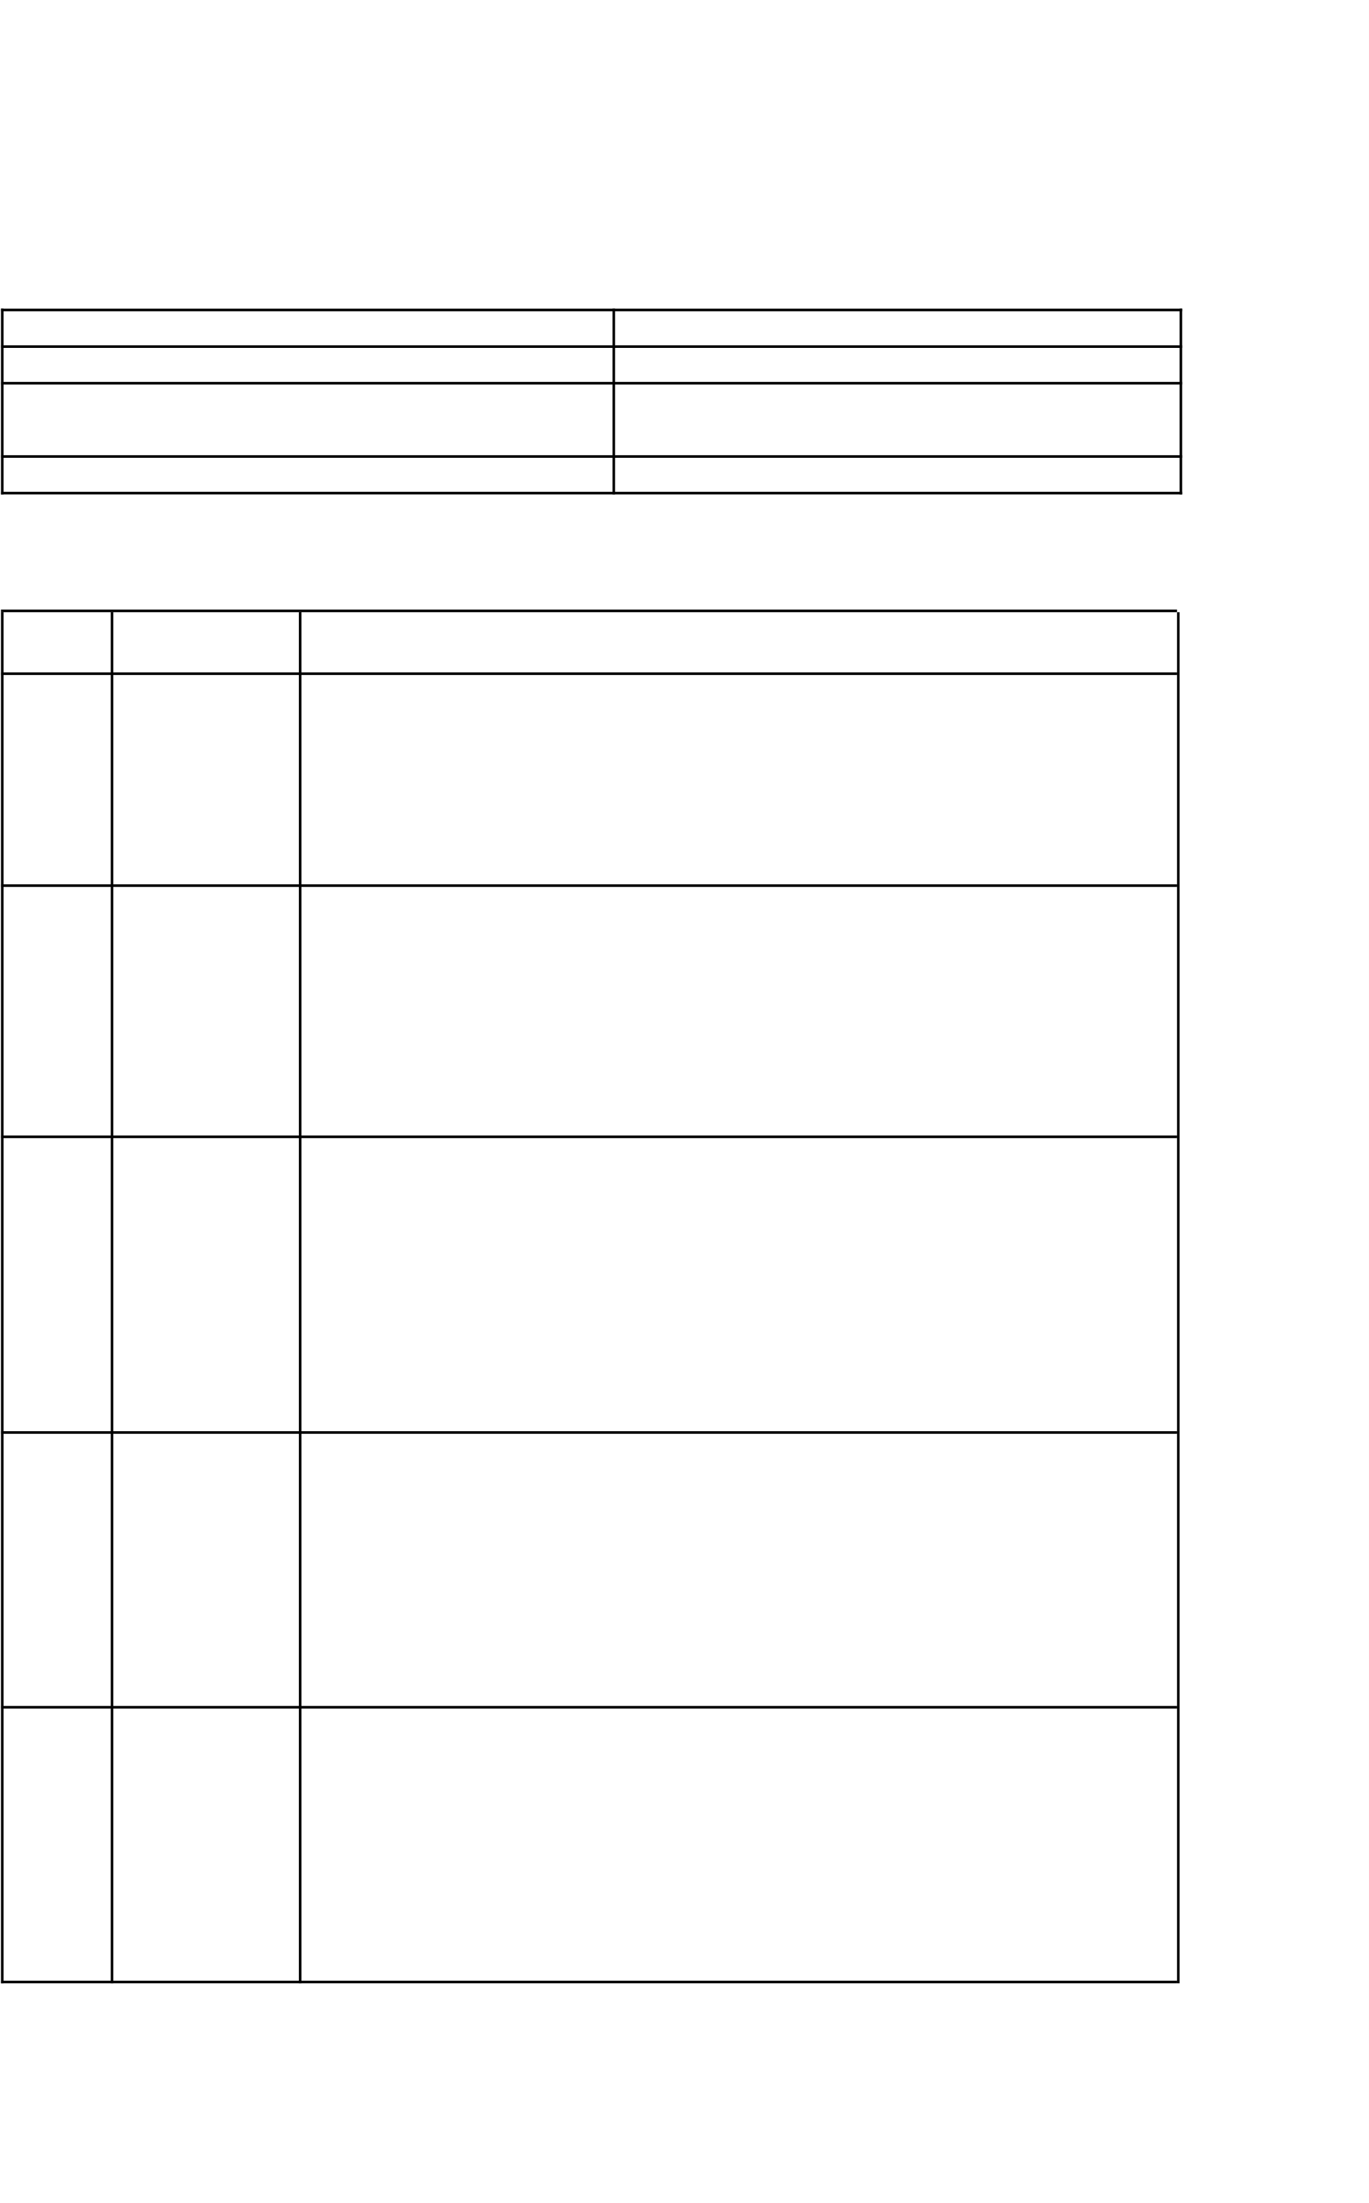
- Idea /
Solution Description

- Novelty / Uniqueness

- Social Impact
/ Customer Satisfaction

- Business
Model (Revenue
Model)
time updates, transparency, and smooth order handling.
ShopEase is a web-based e-commerce platform where customers can browse products, compare prices, check availability, and purchase items easily.
Sellers can manage their inventory, update product details, and track orders, while admins can approve products, manage users, and maintain platform quality.
The system ensures real-time stock updates, secure payment processing, and smooth communication across all user types.
- Unified system for customers, sellers, and admins
- Real-time stock visibility and order status updates
- Seller onboarding, product approval, and verification managed by admin
- Smart product search with filters, recommendations, and price comparison
- Easy checkout experience with multiple payment options

- Makes online shopping more accessible, reliable, and transparent
- Helps small businesses and sellers reach a larger customer base
- Enhances trust through verified sellers, genuine reviews, and secure payments
- Reduces customer frustration by offering faster checkout and better

tracking

- Free access for customers to browse and purchase products
- Sellers pay small fees for listing boosts / featured placements
- Optional premium subscription for sellers offering analytics, sales insights, and promotional tools
- Future revenue channels include ad placements, express delivery

charges, and affiliate partnerships


- Scalability of the Solution
- Can expand to multiple regions, categories, and seller types
- Ready for mobile app integration using React Native
- Modular architecture supports additional features like AI recommendations, chat support, and digital wallets
- Designed to handle increasing users, sellers, products, and orders efficiently

